Institute of Technology Tallaght
Department of Computing

National Diploma in Computing

Operating Systems
Memory Management

- The allocation of main memory to processes in a contiguous memory system using variable partition multiprogramming is shown in this diagram:

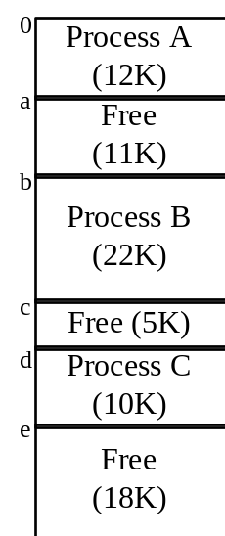

- Show the final Free Storage List and how it would be maintained under each of the following placement strategies: First-fit, Best-fit, Worst-Fit for the following events :
- Process D arrives requesting 4K of memory

First-Fit:
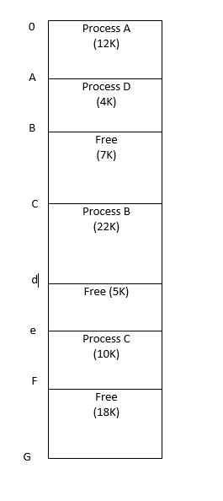

Best-Fit:
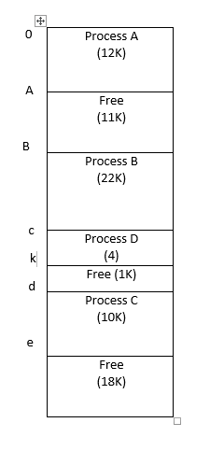

Worst-Fit:
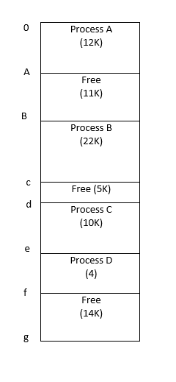
- Process D arrives, requesting 15K of memory, and

First-Fit:
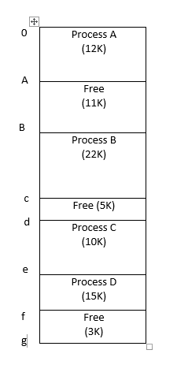

Best-Fit:

Worst-Fit:
(3) Process C terminates.
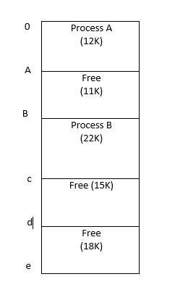

2. Consider a contiguous allocation variable partition multiprogramming system, which contains the following holes (in order): 128K, 512K, 256K, and 622K. Processes A, B, C, and D arrive in order and request 212K, 417K, 112K and 426K respectively.
Show how the best fit, worst fit, and first fit algorithms would place these processes.

First-Fit:
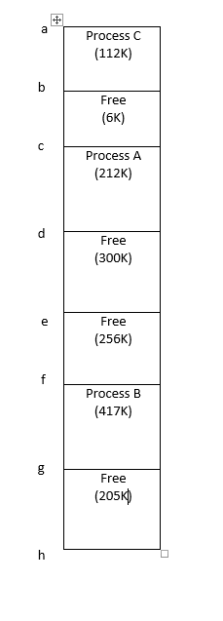

Best-Fit:
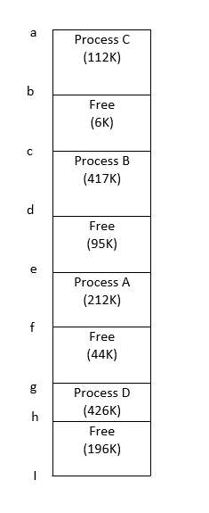

Worst-Fit:
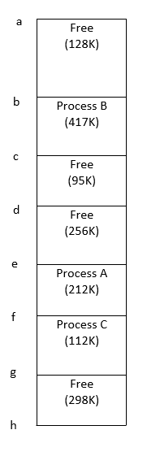

Which makes best use of memory in this case?
In this case, Best fit makes best use of memory. This is because in Worst-Fit and First Fit, the processes occupied the memory inefficiently, leaving free holes smaller than that required by the process.
- Consider a Page Based Operating System that uses Direct Mapping. The pages are 4 bytes in size. The CPU requests virtual address

3 | 2

The Page Map Table and Physical Memory (divided into Page Frames) are shown to the right.

- What do the “3” and “2” in the virtual address represent?
“3” is the page map address in the page map table in the
Virtual address.
“2” is the displacement in the physical memory in the virtual address.
- What data will be retrieved by this request? Draw a diagram showing how the real address is computed.

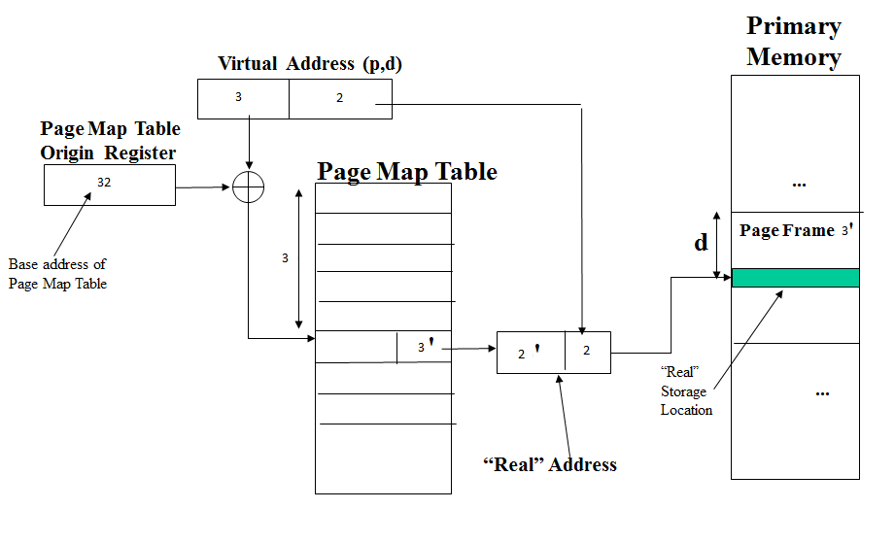

- A combined associative/direct mapping paging system has a hit ratio of 80%. It takes 20nS to access the Associative Storage, and 100nS to access real storage. On average, how long will it take to access a page in memory?

Page Map Table Physical Memory
 | 5 |  |  | 0 | a
 | 6 |  |  |  | t
 | 1 |  |  |  | h
 | 2 |  |  |  | w
 | 7 |  |  | 1 | e
 |  |  |  |  | i
 |  |  |  |  | p
 |  |  |  |  | o
 |  |  |  | 2 | q
 |  |  |  |  | n
 |  |  |  |  | l
 |  |  |  |  | m
 |  |  |  | 3 | e
 |  |  |  |  | i
 |  |  |  |  | p
 |  |  |  |  | o
 |  |  |  | 4 | q
 |  |  |  |  | l
 |  |  |  |  | m
 |  |  |  |  | a
 |  |  |  | 5 | q
 |  |  |  |  | l
 |  |  |  |  | m
 |  |  |  |  | a
 |  |  |  | 6 | e
 |  |  |  |  | i
 |  |  |  |  | p
 |  |  |  |  | o
 |  |  |  | 7 | q
 |  |  |  |  | l
 |  |  |  |  | m
 |  |  |  |  | a

